# Javascript Ajax and Fetch

<https://www.linkedin.com/learning/javascript-ajax-and-fetch-24655836>

github: [LinkedInLearning/JavaScript-Ajax-and-Fetch-3809063: This is a code repository for the LinkedIn Learning course Javascript: Ajax and Fetch.](https://github.com/LinkedInLearning/JavaScript-Ajax-and-Fetch-3809063)

Word wrap and Live Server extension:

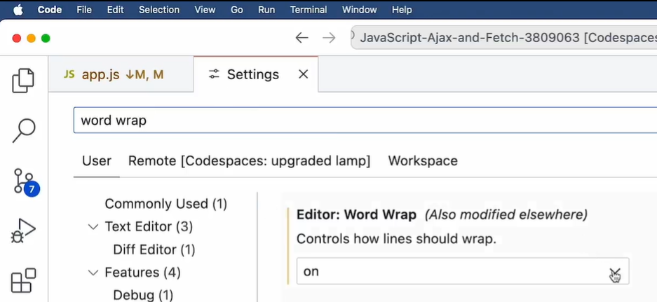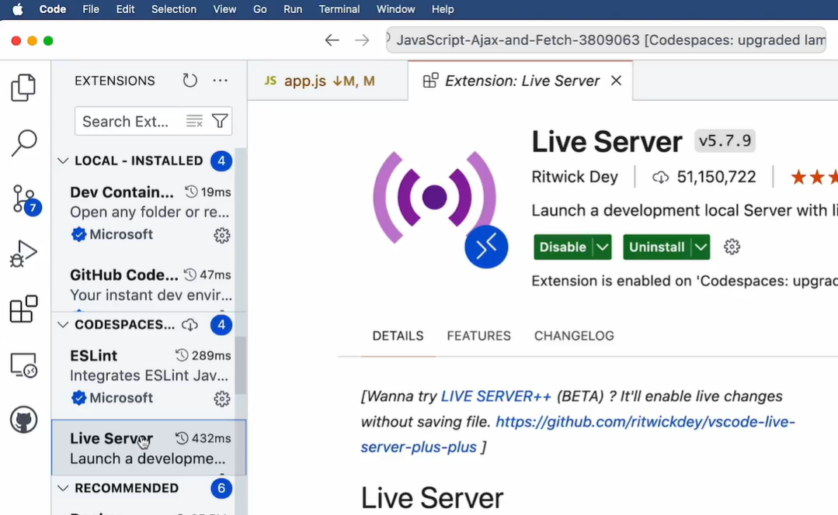

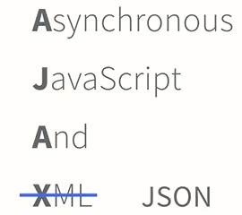

I want to get an Api and use it, so Register in geocod.io:  
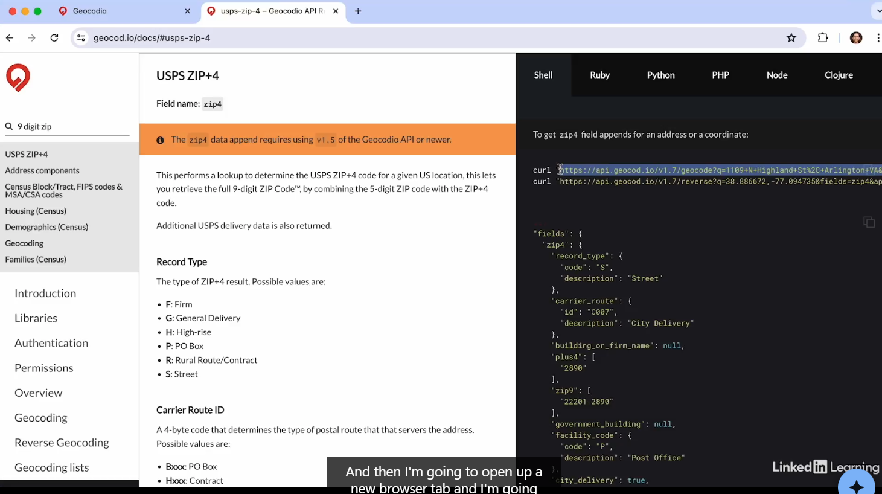

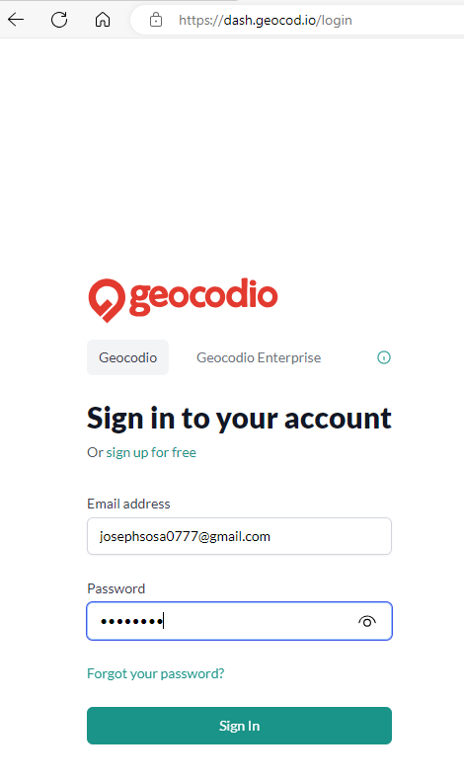 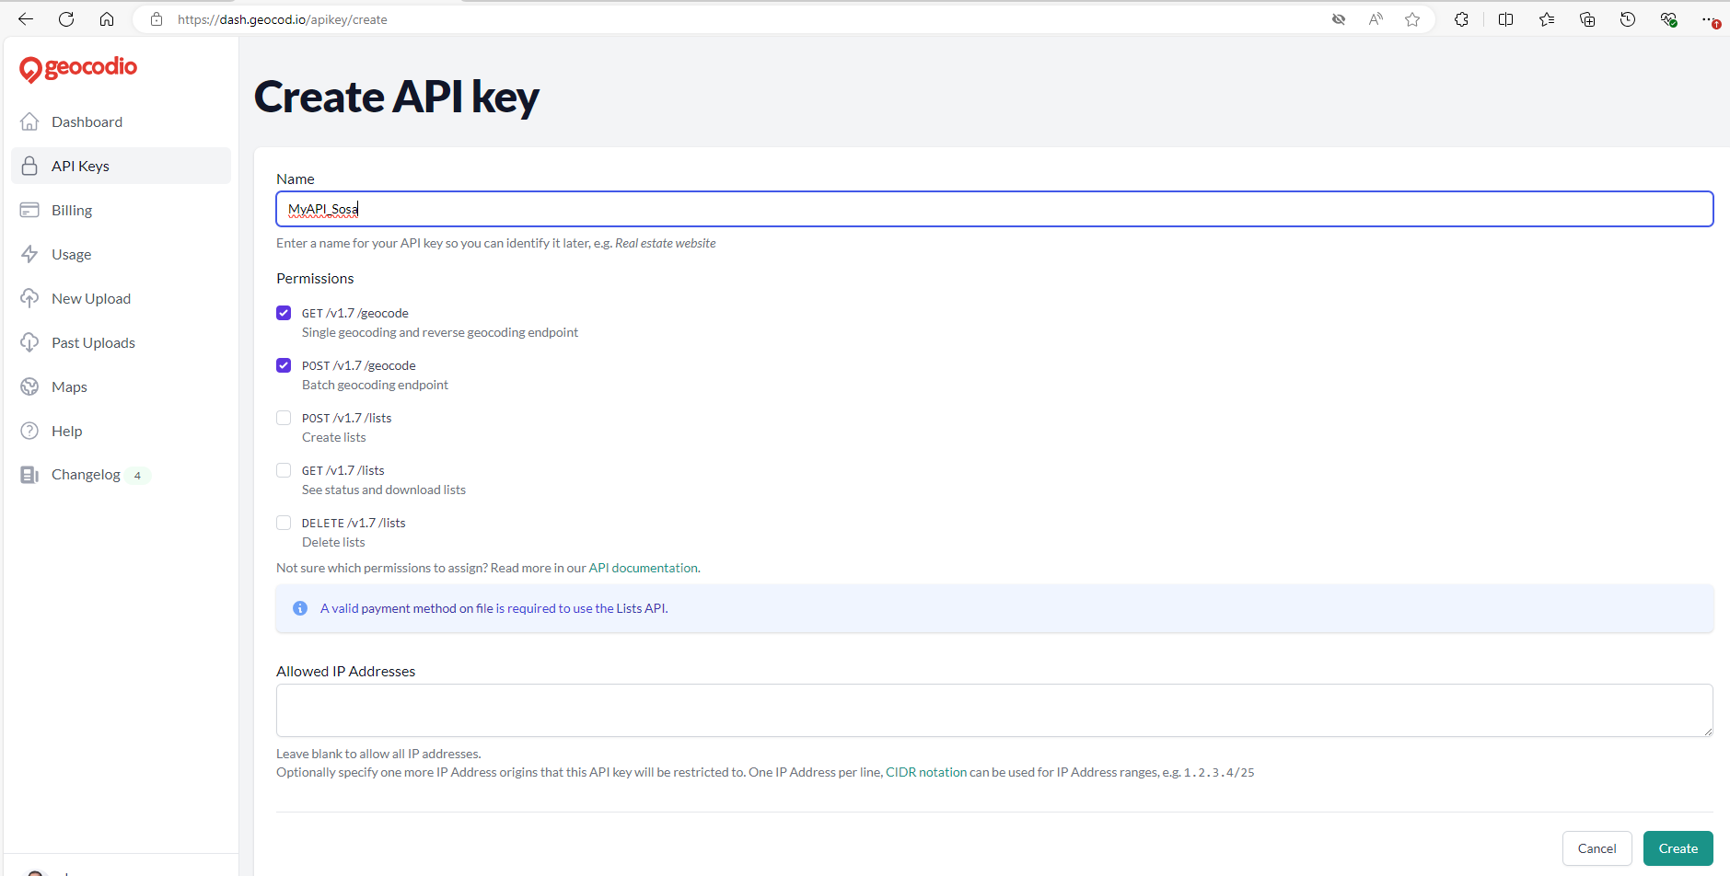

API key: 78378d8185b632b34721866b2d756683d156577

Go to   
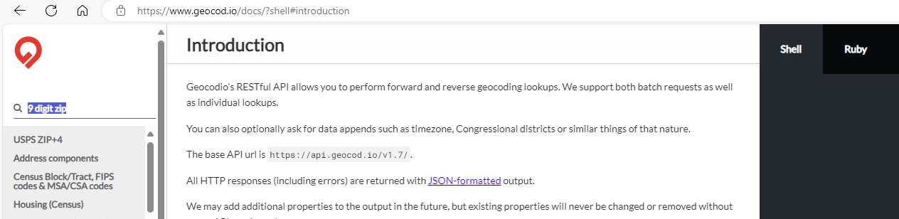  
and search 9 digit zip, and select USPS ZIP+4 and copy the url:

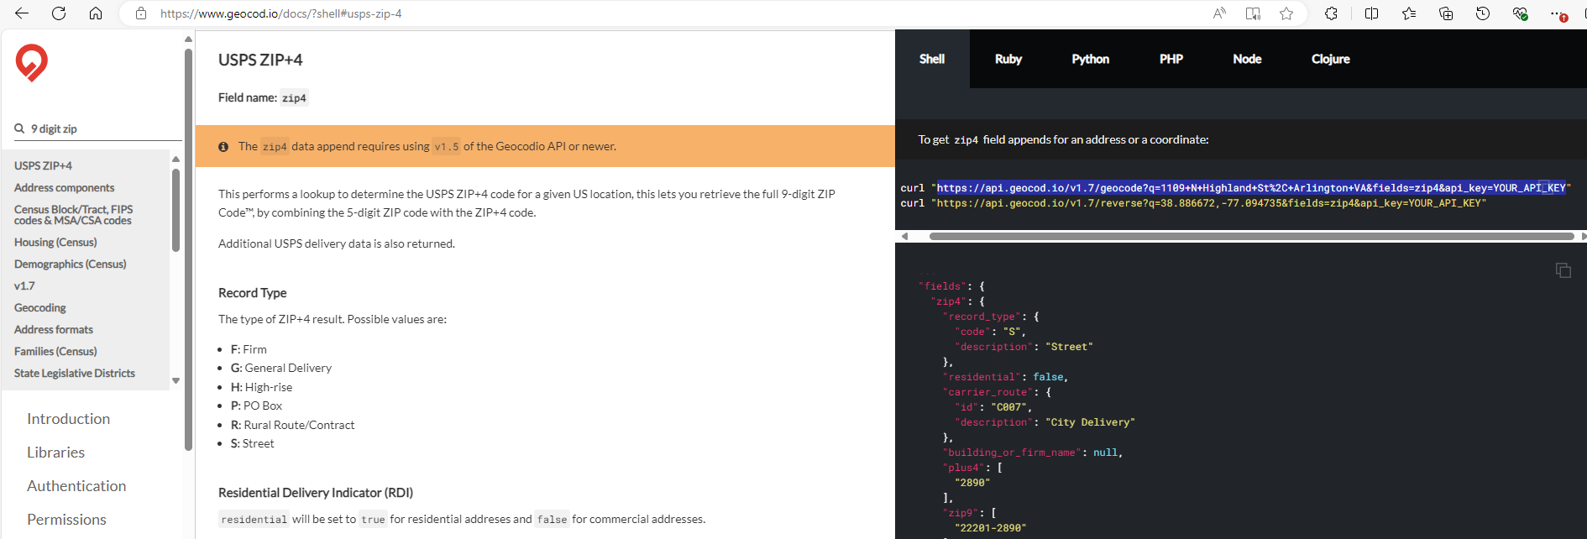

<https://api.geocod.io/v1.7/geocode?q=1109+N+Highland+St%2C+Arlington+VA&fields=zip4&api_key=YOUR_API_KEY%22%20curl%20%22https://api.geocod.io/v1.7/reverse?q=38.886672,-77.094735&fields=zip4&api_key=78378d8185b632b34721866b2d756683d156577>

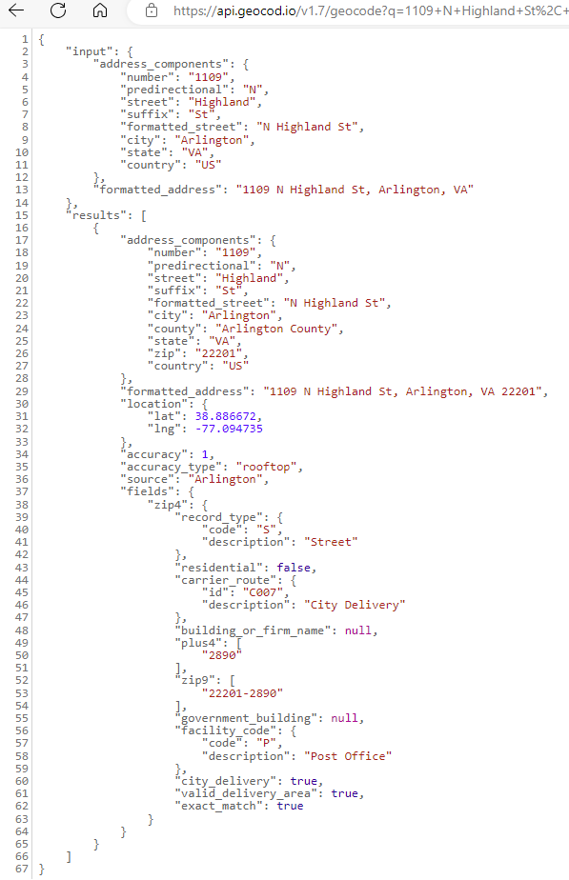

Challenge. Get info from API:  
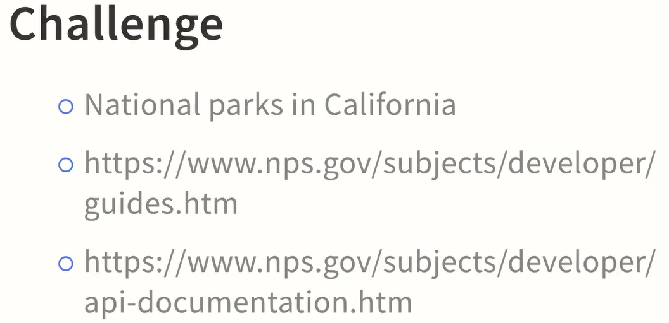

[API Guides - Developer Resources (U.S. National Park Service)](https://www.nps.gov/subjects/developer/guides.htm)

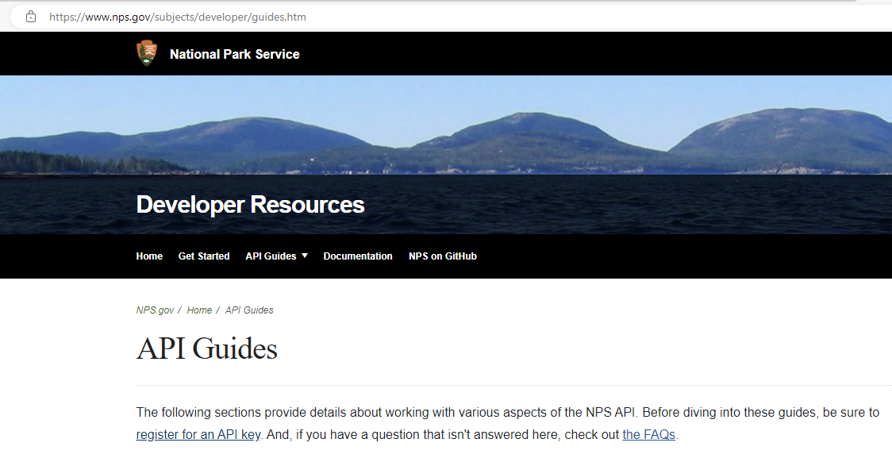

It’s necessary to register to get an API key

tLj4PDq0LInJI6eArgkrb1yuiNcgwSauRH6CMy7d

[API Documentation - Developer Resources (U.S. National Park Service)](https://www.nps.gov/subjects/developer/api-documentation.htm)

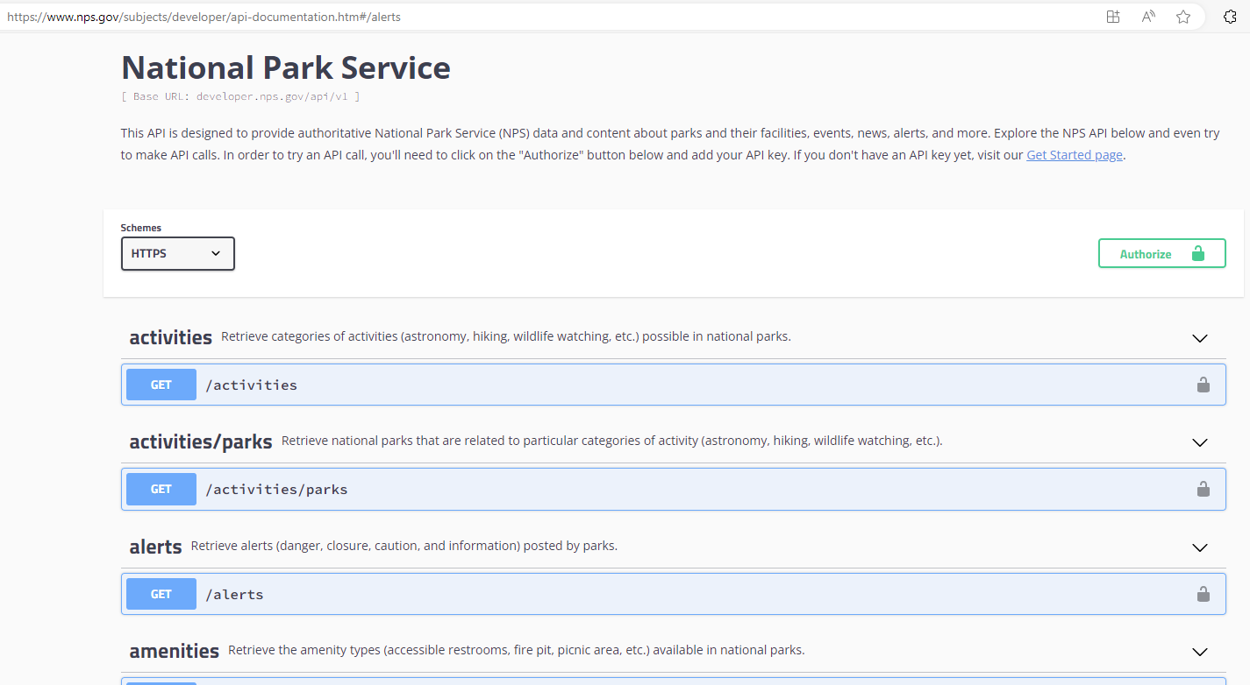

A page that uses ajax requests data in the background and then integrates it into the document displayed in the browser window is an example of ajax in web page.

## Fetch

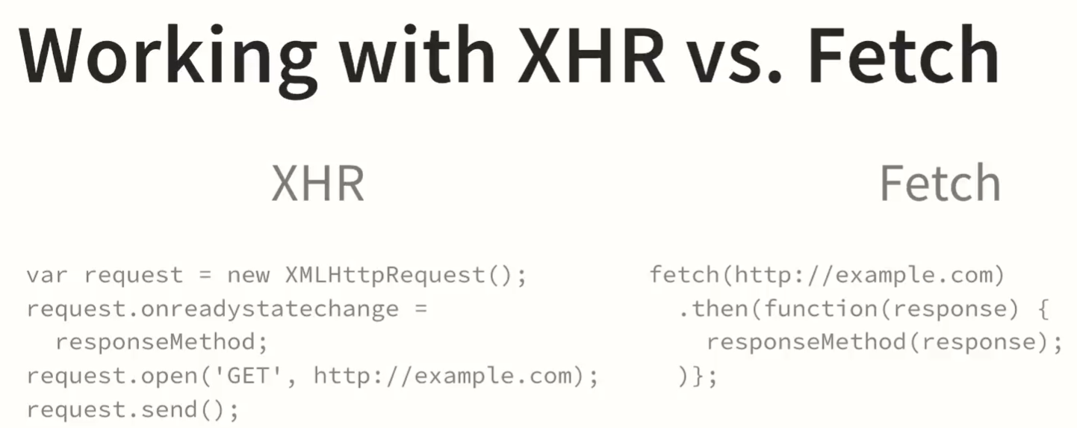

Fetch and jquery based in promises.

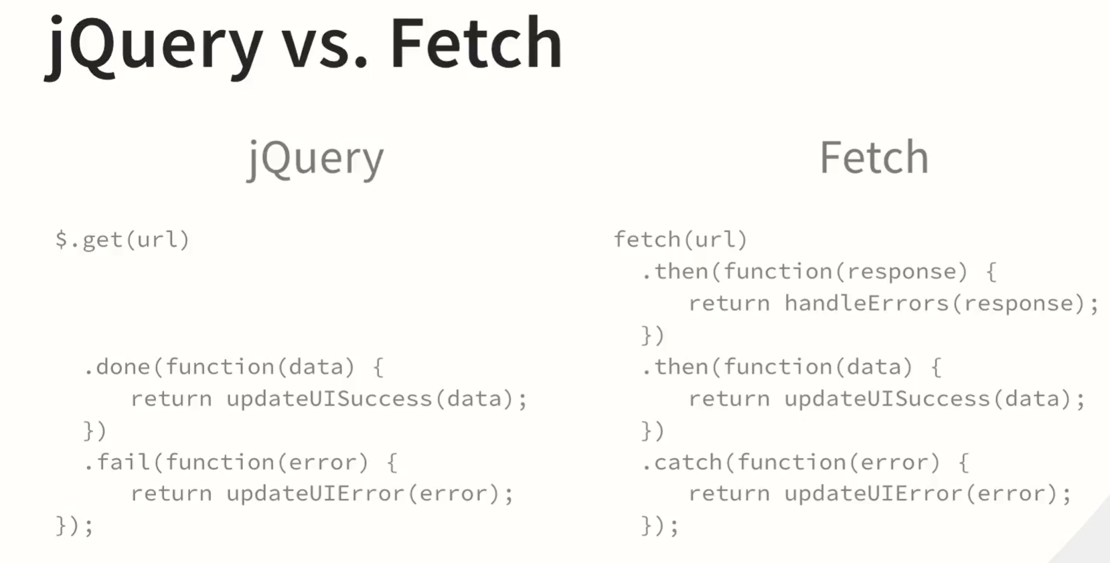

Also is common to see the fetch using arrow functions:

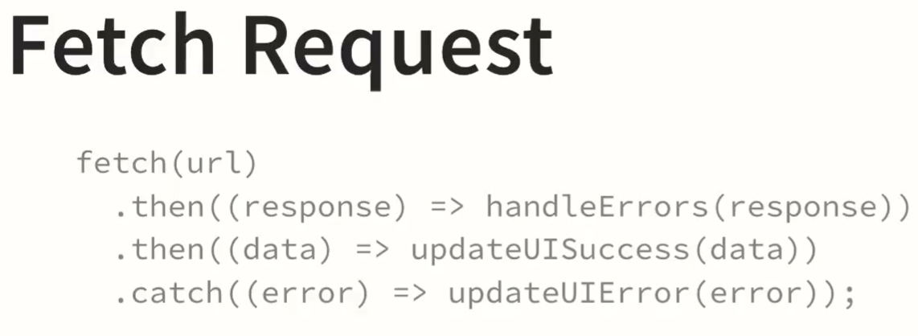

<https://caniuse.com> to see current level of support of browsers for features in HTML, CSS and JavaScript

Create app.js:

'use strict';

const geocodioUrl = 'https://api.geocod.io/v1.7/geocode?q=1109+N+Highland+St%2C+Arlington+VA&fields=zip4&api_key=6685cecc728ce276c6e82c17278888218268186';

const createRequest = (url) => {

  fetch(url)

    .then((response) => response.json())

    .then((data) => console.log(data));

};

createRequest(geocodioUrl);

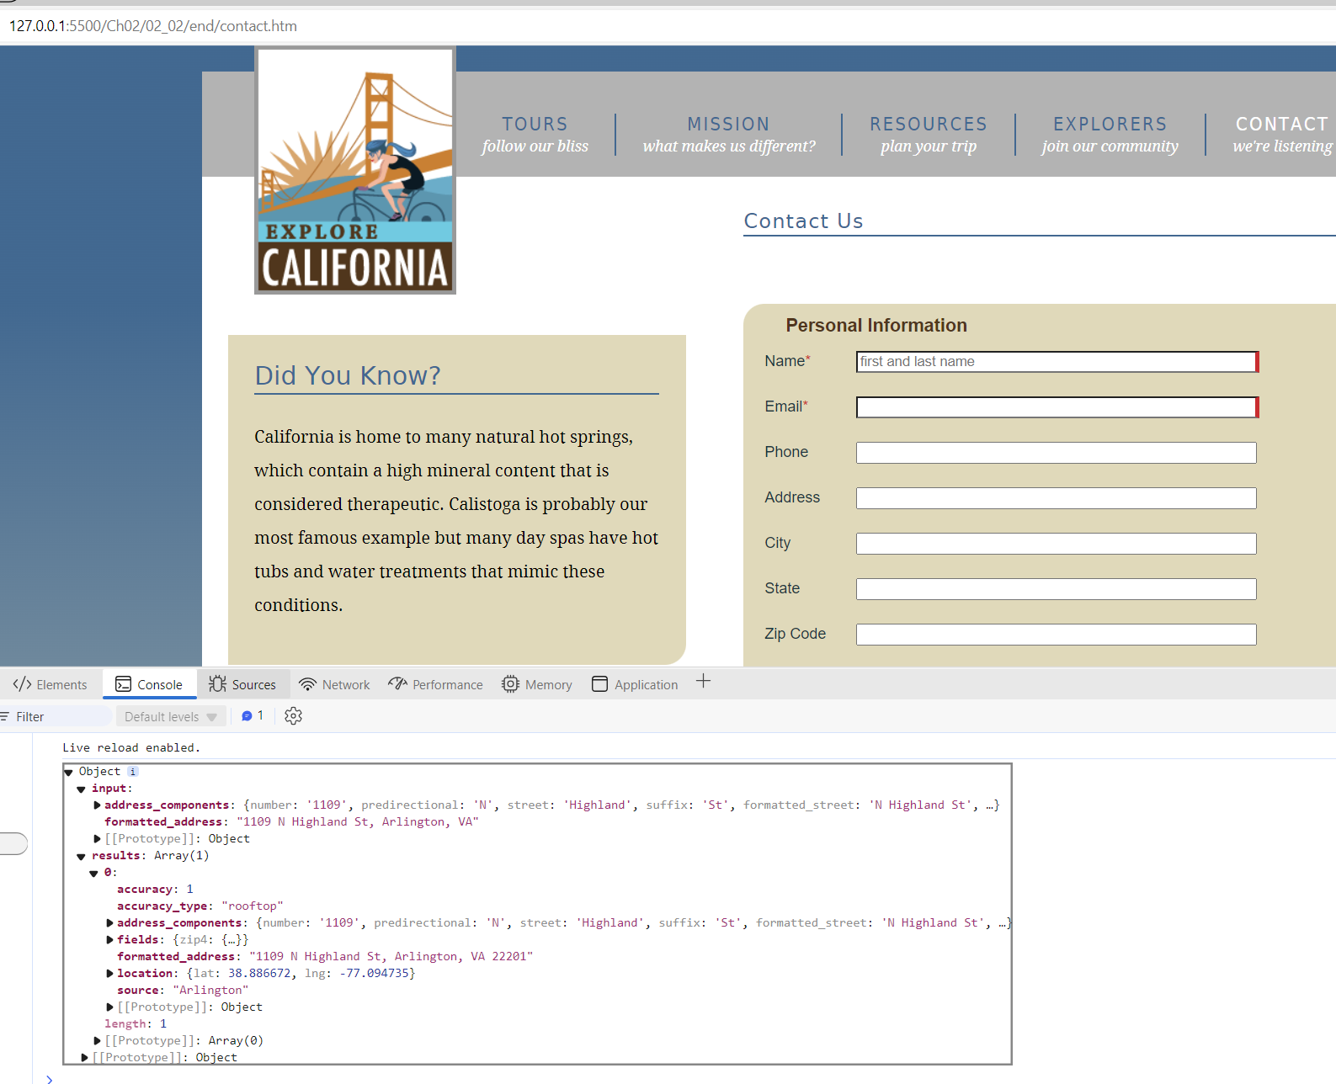

'use strict';

const geocodioUrl = 'https://api.geocod.io/v1.7/geocode?q=1109+N+Highland+St%2C+Arlington+VA&fields=zip4&api_key=6685cecc728ce276c6e82c17278888218268186';

const createRequest = (url) => {

  fetch(url)

    .then(function(response) {

      console.log("resp ", response.status);

      return response.json();

    })

    .then((data) => console.log("data ", data));

};

createRequest(geocodioUrl);

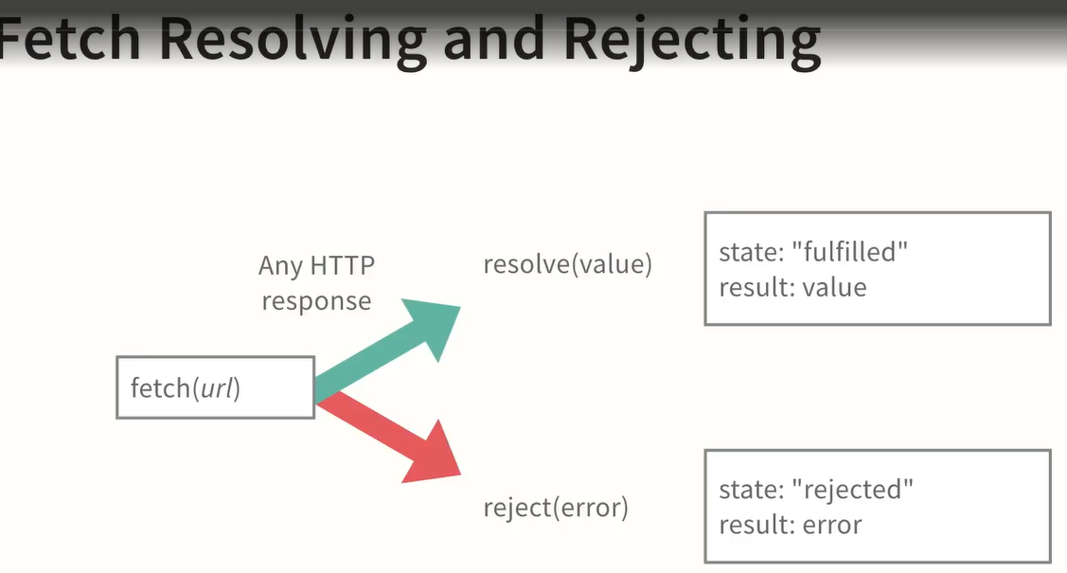

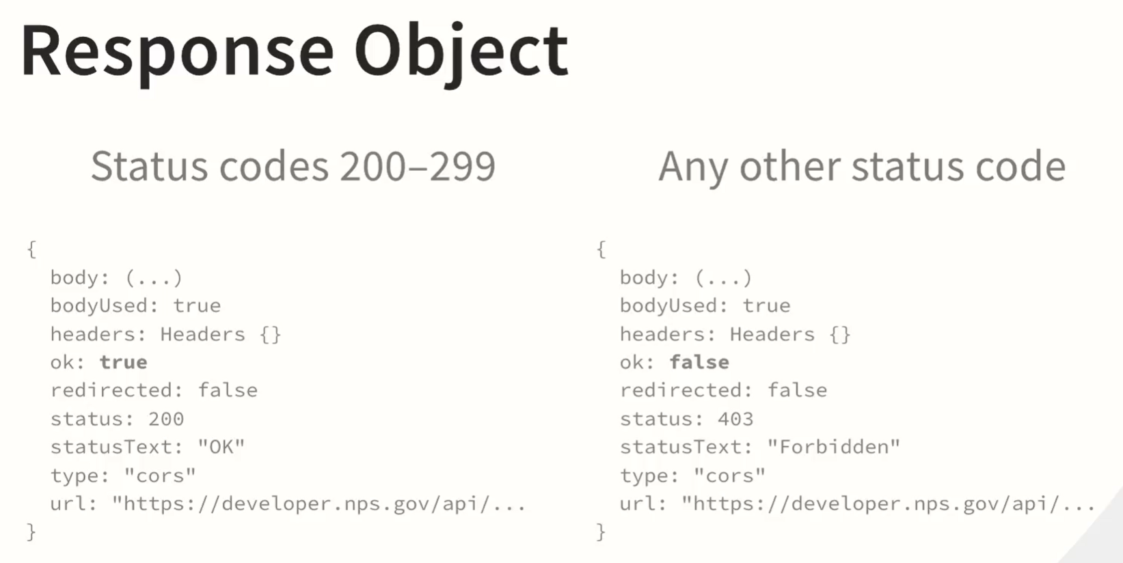

'use strict';

const geocodioUrl = 'https://api.geocod.io/v1.7/geocode?q=1109+N+Highland+St%2C+Arlington+VA&fields=zip4&api_key=6685cecc728ce276c6e82c17278888218268186';

const handleErrors = (response) => {

   if (response.ok) return response.json();

   return response.json()

     .then(response => {throw new Error(response.error.message || response.error)})

};

const handleSuccess = (data) => {

  console.log(data)

};

const createRequest = (url) => {

  fetch(url)

    .then((response) => handleErrors(response))

    .then((data) => handleSuccess(data))

    .catch((error) => console.error(error))

};

createRequest(geocodioUrl);

if I have an invalid API key:

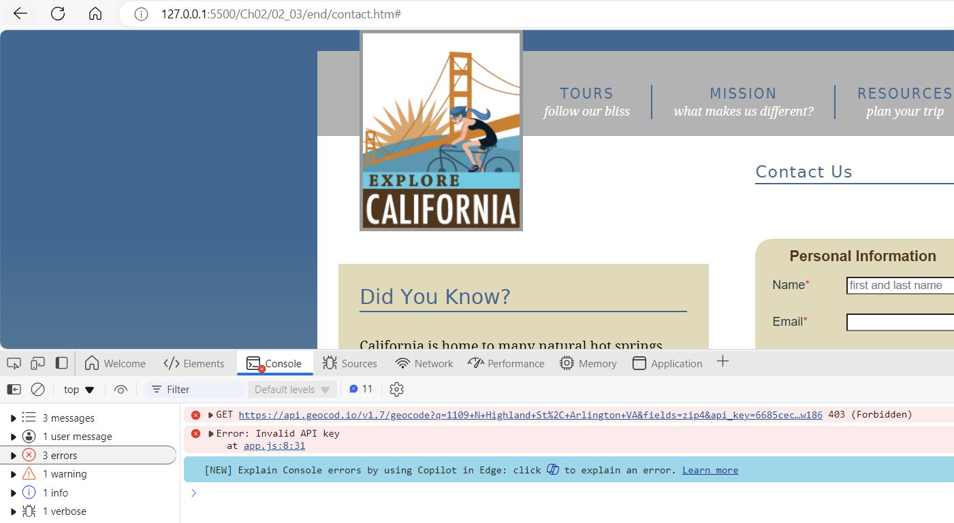

Challenge. Exercise 02_05

https://developer.nps.gov/api/v1/parks?parkCode=&stateCode=CA&api_key=tLj4PDq0LInJI6eArgkrb1yuiNcgwSauRH6CMy7d

'use strict';

const geocodioUrl = 'https://api.geocod.io/v1.7/geocode?q=1109+N+Highland+St%2C+Arlington+VA&fields=zip4&api_key=6685cecc728ce276c6e82c17278888218268186';

const npsUrl = 'https://developer.nps.gov/api/v1/parks?stateCode=CA&api_key=CNJUTrcuXaoHqVeIxmB8d0GMVLQd0WfCU7zfThQK';

const handleErrors = (response) => {

   if (response.ok) return response.json();

   return response.json()

     .then(response => {throw new Error(response.error.message || response.error)})

};

const handleSuccess = (data) => {

  console.log(data)

};

const createRequest = (url) => {

  fetch(url)

    .then((response) => handleErrors(response))

    .then((data) => handleSuccess(data))

    .catch((error) => console.error(error))

};

createRequest(geocodioUrl);

createRequest(npsUrl);

## Methods for selecting elements in the DOM and use of event listener

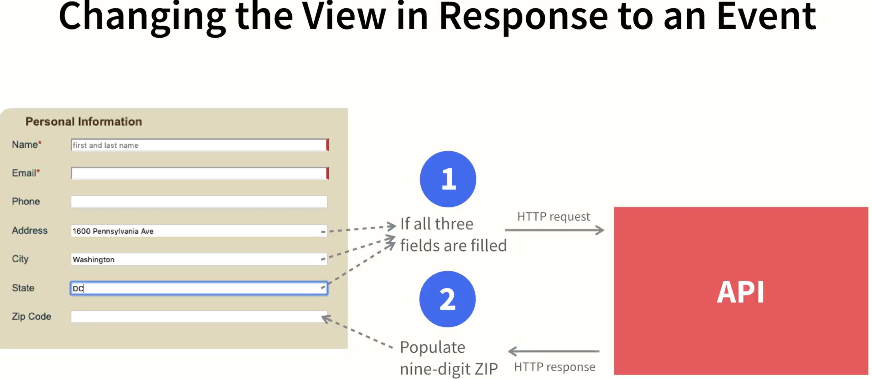

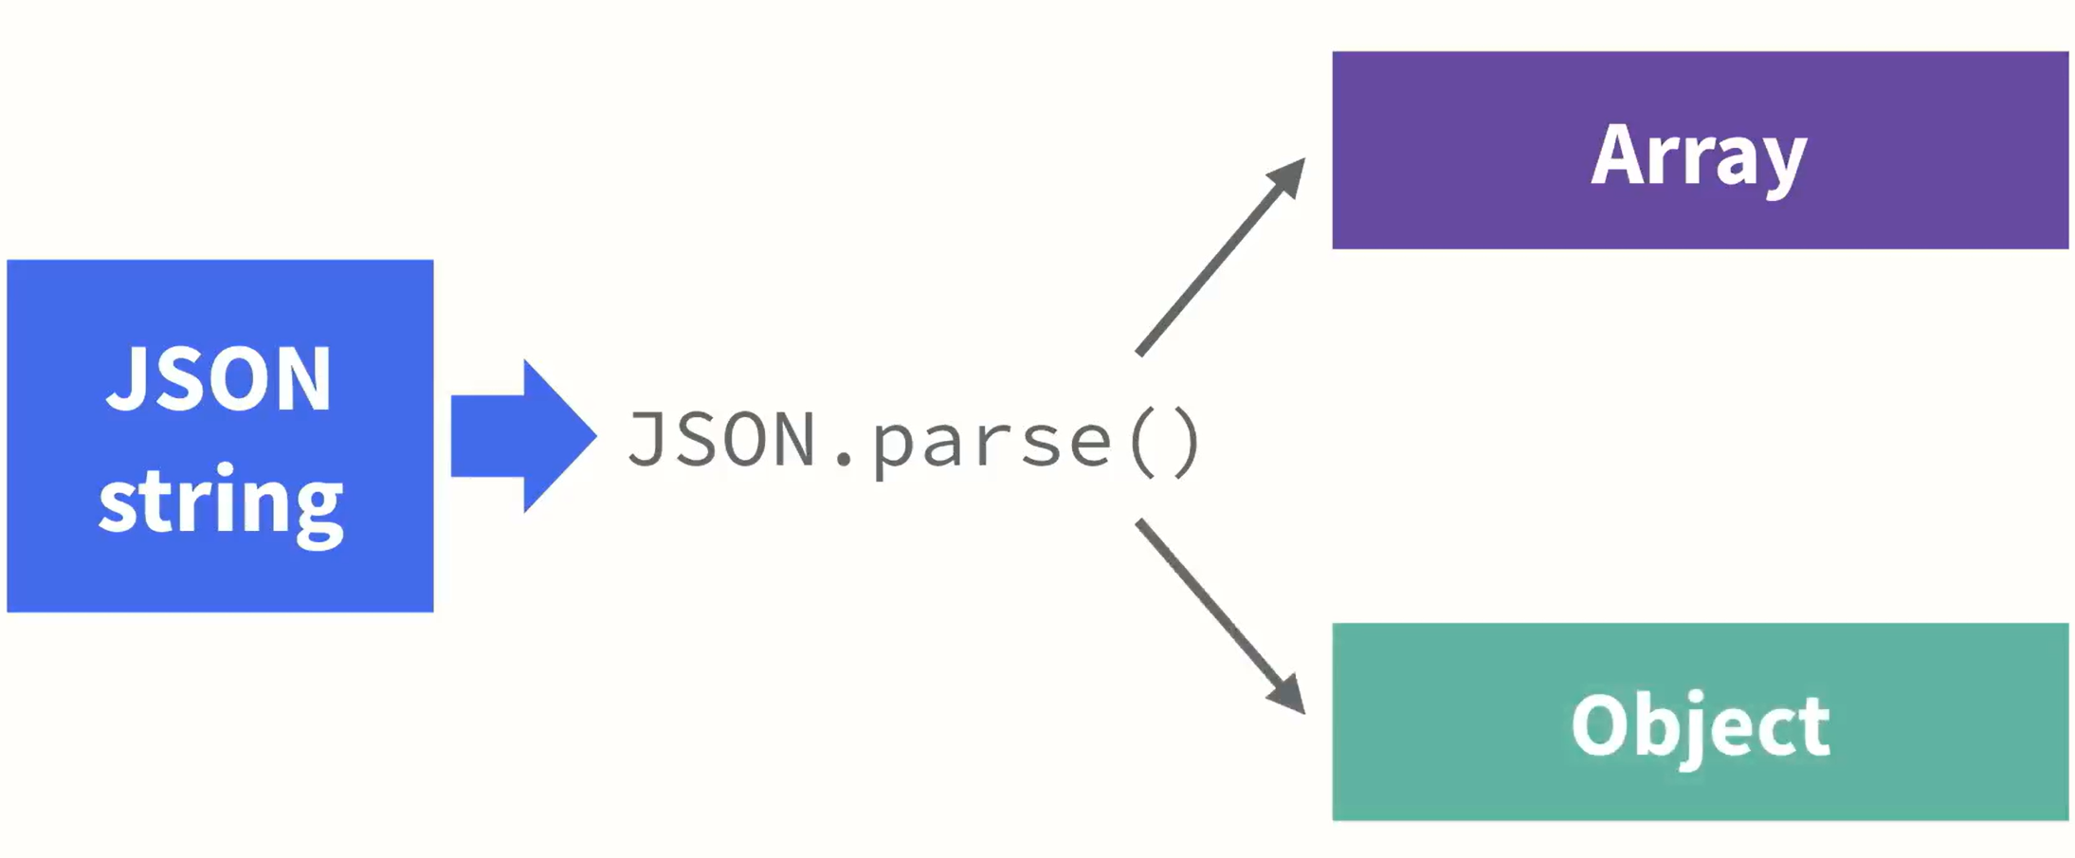 but not required here.

Example Exercise 03_06

'use strict';

// const geocodioUrl = 'https://api.geocod.io/v1.7/geocode?q=1109+N+Highland+St%2C+Arlington+VA&fields=zip4&api_key=6685cecc728ce276c6e82c17278888218268186';

const geocodioBaseUrl = 'https://api.geocod.io/v1.7/geocode?q=';

const geocodioApiKey = '6685cecc728ce276c6e82c17278888218268186'

const npsUrl = 'https://developer.nps.gov/api/v1/parks?stateCode=CA&api_key=CNJUTrcuXaoHqVeIxmB8d0GMVLQd0WfCU7zfThQK';

const addressField = document.querySelector('#address');

const cityField = document.querySelector('#city');

const stateField = document.querySelector('#state');

// const $zipField = $('#zip');

const zipField = document.querySelector('#zip');

const handleGeocodioErrors = (response) => {

   if (response.ok) return response.json();

   return response.json()

     .then(response => {throw new Error(response.error.message || response.error)})

};

const handleParkErrors = (response) => {

   if (response.ok) return response.json();

   return response.json()

     .then(response => {throw new Error(response.error.message || response.error)})

};

const handleGeocodioSuccess = (data) => {

  // console.log(data)

  const zip9 = data.results[0].fields.zip4.zip9[0];

  // console.log(zip9);

  zipField.value = zip9;

};

const handleParkSuccess = (data) => {

  console.log(data);

}

const createRequest = (url, errors, success) => {

  fetch(url)

    .then((response) => errors(response))

    .then((data) => success(data))

    .catch((error) => console.error(error))

};

let checkCompletion = () => {

  if (addressField.value !== '' &&

    cityField.value !== '' &&

    stateField.value !== '') {

    const requestUrl = geocodioBaseUrl +

      addressField.value + '+' +

      cityField.value + '+' +

      stateField.value +

      '&fields=zip4' +

      '&api_key=' + geocodioApiKey;

    createRequest(requestUrl, handleGeocodioErrors, handleGeocodioSuccess);

  }

}

// createRequest(geocodioUrl);

createRequest(npsUrl, handleParkErrors, handleParkSuccess);

addressField.addEventListener('blur', checkCompletion);

cityField.addEventListener('blur', checkCompletion);

stateField.addEventListener('blur', checkCompletion);

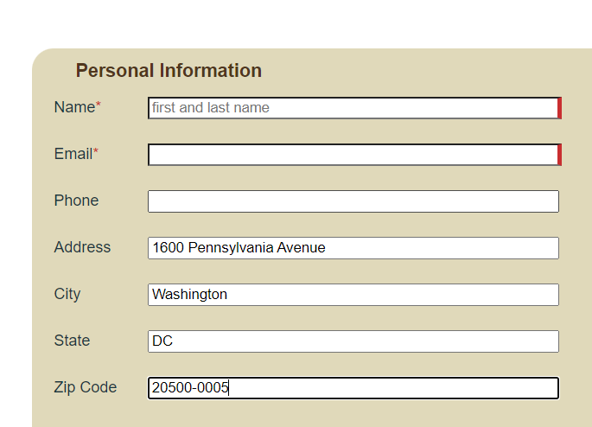

Getting & Set Content in DOM elements:

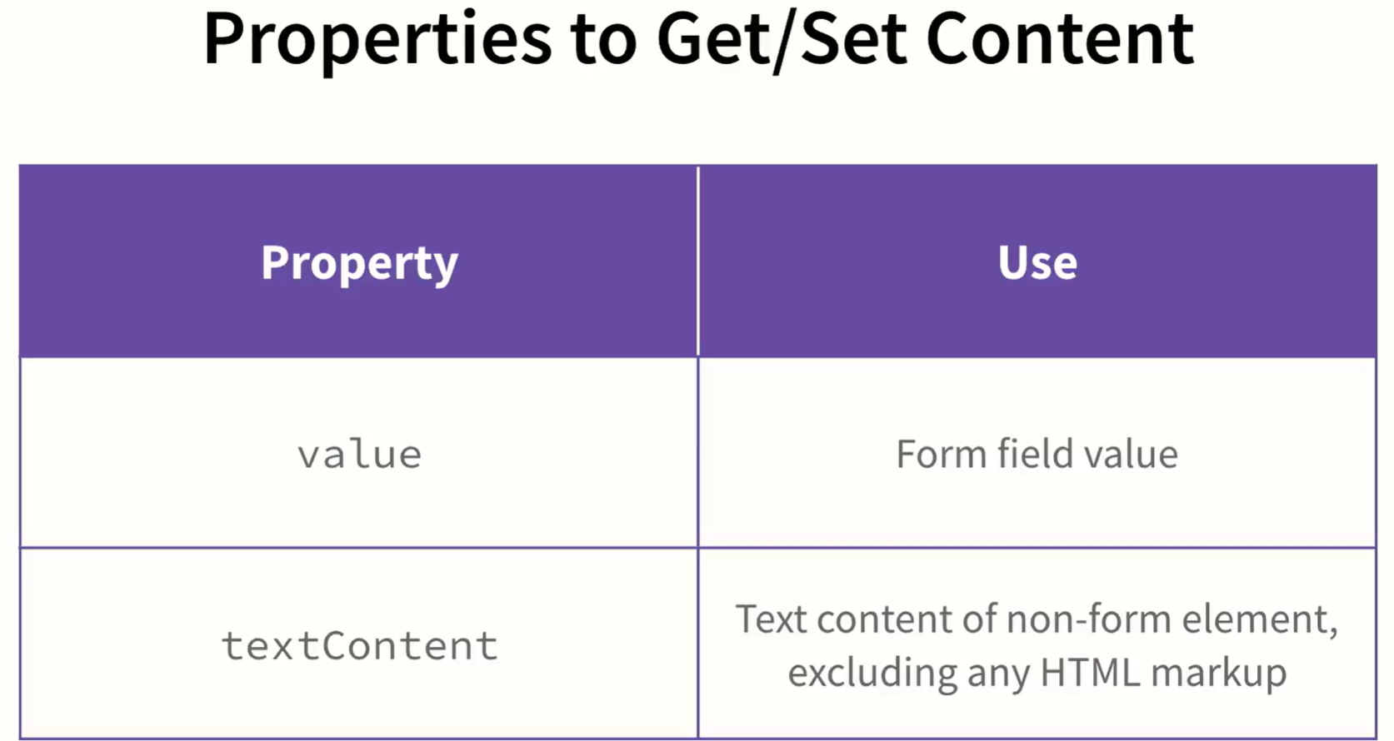

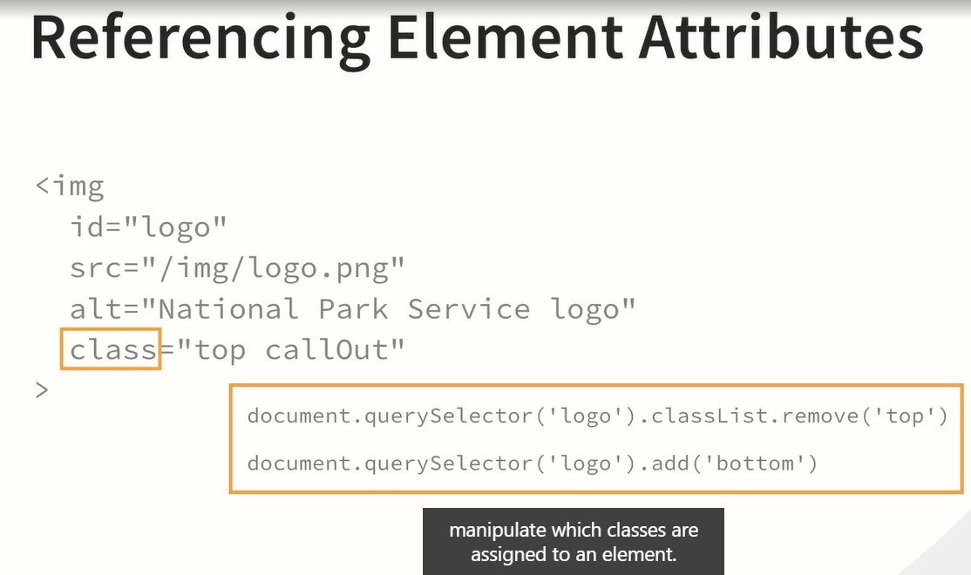

Example access:

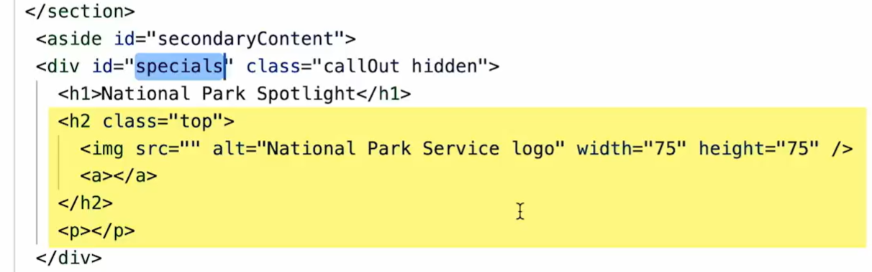

Get the element using querySelector:

Challenge Modify DOM

 → 

Code to add data randomly after the DOM is loaded:

'use strict';

// const geocodioUrl = 'https://api.geocod.io/v1.7/geocode?q=1109+N+Highland+St%2C+Arlington+VA&fields=zip4&api_key=6685cecc728ce276c6e82c17278888218268186';

const geocodioBaseUrl = 'https://api.geocod.io/v1.7/geocode?q=';

const geocodioApiKey = '6685cecc728ce276c6e82c17278888218268186'

const npsUrl = 'https://developer.nps.gov/api/v1/parks?stateCode=CA&api_key=CNJUTrcuXaoHqVeIxmB8d0GMVLQd0WfCU7zfThQK';

const addressField = document.querySelector('#address');

const cityField = document.querySelector('#city');

const stateField = document.querySelector('#state');

// const $zipField = $('#zip');

const zipField = document.querySelector('#zip');

const parkSection = document.querySelector('#specials');

const parkThumb = document.querySelector('#specials h2 img');

**const parkName = document.querySelector('#specials h2 a');**

**const parkDesc = document.querySelector('#specials p');**

const handleGeocodioErrors = (response) => {

   if (response.ok) return response.json();

   return response.json()

     .then(response => {throw new Error(response.error.message || response.error)})

};

const handleParkErrors = (response) => {

   if (response.ok) return response.json();

   return response.json()

     .then(response => {throw new Error(response.error.message || response.error)})

};

const handleGeocodioSuccess = (data) => {

  // console.log(data)

  const zip9 = data.results[0].fields.zip4.zip9[0];

  // console.log(zip9);

  zipField.value = zip9;

};

const handleParkSuccess = (data) => {

  console.log(data);

  parkThumb.src = '_images/nps_logo.svg';

**const randNum = Math.floor(Math.random() * (data.data.length));**

**parkName.textContent = data.data[randNum].fullName;**

**parkName.href = data.data[randNum].url;**

**parkDesc.textContent = data.data[randNum].description;**

**parkSection.classList.remove('hidden');**

}

const createRequest = (url, errors, success) => {

  fetch(url)

    .then((response) => errors(response))

    .then((data) => success(data))

    .catch((error) => console.error(error))

};

let checkCompletion = () => {

  if (addressField.value !== '' &&

    cityField.value !== '' &&

    stateField.value !== '') {

    const requestUrl = geocodioBaseUrl +

      addressField.value + '+' +

      cityField.value + '+' +

      stateField.value +

      '&fields=zip4' +

      '&api_key=' + geocodioApiKey;

    createRequest(requestUrl, handleGeocodioErrors, handleGeocodioSuccess);

  }

}

// createRequest(geocodioUrl);

window.addEventListener('DOMContentLoaded', () => {

  createRequest(npsUrl, handleParkErrors, handleParkSuccess);

});

addressField.addEventListener('blur', checkCompletion);

cityField.addEventListener('blur', checkCompletion);

stateField.addEventListener('blur', checkCompletion);

The ***DOMContentLoaded*** event in JavaScript is triggered when the initial HTML content of the page has been fully loaded and parsed, but before images, stylesheets, or any other external resources are loaded.

## Working with Axios

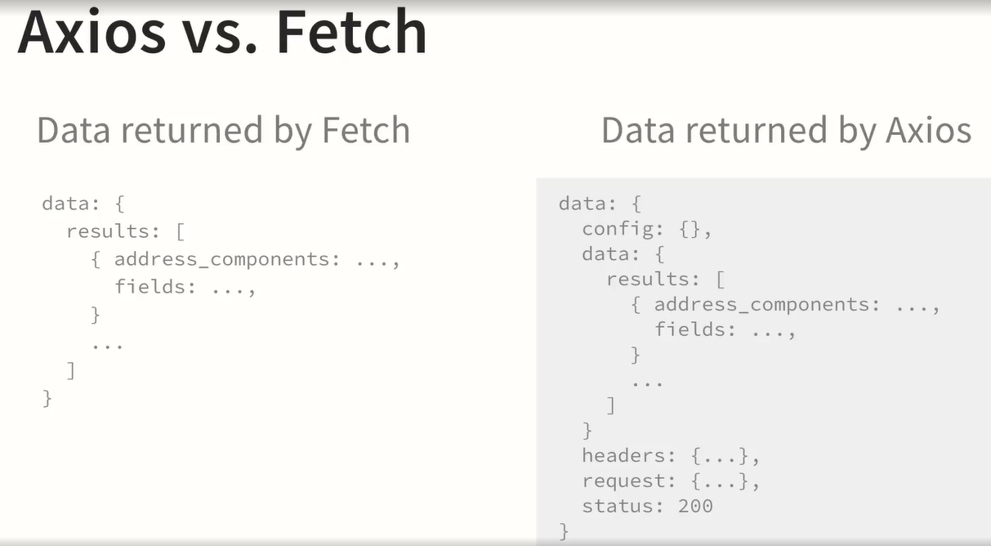

Example using axios:

In the .htm include:

<script src="https://cdn.jsdelivr.net/npm/axios/dist/axios.min.js"></script>

In the app.js:

'use strict';

// const geocodioUrl = 'https://api.geocod.io/v1.7/geocode?q=1109+N+Highland+St%2C+Arlington+VA&fields=zip4&api_key=6685cecc728ce276c6e82c17278888218268186';

// const geocodioBaseUrl = 'https://api.geocod.io/v1.7/geocode?q=';

const geocodioBaseUrl = 'https://api.geocod.io/v1.7/geocode';

const geocodioApiKey = '6685cecc728ce276c6e82c17278888218268186'

const npsUrl = 'https://developer.nps.gov/api/v1/parks?stateCode=CA&api_key=CNJUTrcuXaoHqVeIxmB8d0GMVLQd0WfCU7zfThQK';

const addressField = document.querySelector('#address');

const cityField = document.querySelector('#city');

const stateField = document.querySelector('#state');

// const $zipField = $('#zip');

const zipField = document.querySelector('#zip');

const parkSection = document.querySelector('#specials');

const parkThumb = document.querySelector('#specials h2 img');

const parkName = document.querySelector('#specials h2 a');

const parkDesc = document.querySelector('#specials p');

// const handleGeocodioErrors = (response) => {

//    if (response.ok) return response.json();

//    return response.json()

//      .then(response => {throw new Error(response.error.message || response.error)})

// };

const handleGeocodioErrors = (error) => {

    if (error.response) {

      console.log(error.response);

    } else if (error.request) {

      console.log(error.request);

    } else {

      console.log('Error: ', error.message);

    }

    console.log(error.config);

};

const handleParkErrors = (response) => {

   if (response.ok) return response.json();

   return response.json()

     .then(response => {throw new Error(response.error.message || response.error)})

};

const handleGeocodioSuccess = (data) => {

  // console.log(data)

  const zip9 = **data**.data.results[0].fields.zip4.zip9[0];

  // console.log(zip9);

  zipField.value = zip9;

};

const handleParkSuccess = (data) => {

  console.log(data);

  parkThumb.src = '_images/nps_logo.svg';

  const randNum = Math.floor(Math.random() * (data.data.length));

  parkName.textContent = data.data[randNum].fullName;

  parkName.href = data.data[randNum].url;

  parkDesc.textContent = data.data[randNum].description;

  parkSection.classList.remove('hidden');

}

// const createRequest = (url, errors, success) => {

//   fetch(url)

//     .then((response) => errors(response))

//     .then((data) => success(data))

//     .catch((error) => console.error(error))

// };

**const createRequest = (url, errors, success, params) => {**

**axios.get(url, params)**

**// .then((response) => errors(response))**

**.then((data) => success(data))**

**.catch((error) => errors(error))**

**}**

// let checkCompletion = () => {

//   if (addressField.value !== '' &&

//     cityField.value !== '' &&

//     stateField.value !== '') {

//     const requestUrl = geocodioBaseUrl +

//       addressField.value + '+' +

//       cityField.value + '+' +

//       stateField.value +

//       '&fields=zip4' +

//       '&api_key=' + geocodioApiKey;

//     createRequest(requestUrl, handleGeocodioErrors, handleGeocodioSuccess);

//   }

// }

let checkCompletion = () => {

  if (addressField.value !== '' &&

    cityField.value !== '' &&

    stateField.value !== '') {

    const params = {

      params: {

        'q': addressField.value + '+' +

          cityField.value + '+' +

          stateField.value,

        'fields': 'zip4',

        'api_key': geocodioApiKey

      }

    };

    createRequest(geocodioBaseUrl, handleGeocodioErrors, handleGeocodioSuccess, params);

  }

}

// createRequest(geocodioUrl);

// window.addEventListener('DOMContentLoaded', () => {

//   createRequest(npsUrl, handleParkErrors, handleParkSuccess);

// });

addressField.addEventListener('blur', checkCompletion);

cityField.addEventListener('blur', checkCompletion);

stateField.addEventListener('blur', checkCompletion);

## Axios interceptors

axios.interceptors is a feature of **Axios**, a popular JavaScript library for making HTTP requests. **Interceptors** in Axios allow you to intercept and modify requests or responses before they are sent or processed. This is useful for tasks like adding common headers (e.g., authentication tokens), handling global errors, or transforming data before it's sent or after it's received.

### Types of Interceptors

1. **Request Interceptors**: These allow you to intercept and modify an HTTP request before it is sent.
2. **Response Interceptors**: These allow you to intercept and modify the response you receive from the server before it is processed by your code.

Example request interceptor:

axios.interceptors.request.use(function(config) {

// Modify the request before it is sent

console.log('Request intercepted');

// You can add common headers like an authentication token

config.headers['Authorization'] = 'Bearer ' + token;

return config; // It's important to return the modified config

}, function(error) {

// Handle errors before the request is sent

return Promise.reject(error);

});

Example response:

…

const handleGeocodioSuccess = (data) => {

  // console.log(data)

  // const zip9 = data.data.results[0].fields.zip4.zip9[0];

  // zipField.value = zip9;

  zipField.value = data.zip9;

};

…

const zip9Interceptor = axios.interceptors.response.use((data) => {

  if (data.data.results) {

    const baseZip = data.data.results[0].address_components.zip;

    const plus4 = data.data.results[0].fields.zip4.plus4[0];

    console.log(baseZip + "-" + plus4);

    data.zip9 = baseZip + "-" + plus4;

  }

  return data;

});

Full code fixing error handlers:

'use strict';

// const geocodioBaseUrl = 'https://api.geocod.io/v1.7/geocode?q=';

const geocodioBaseUrl = 'https://api.geocod.io/v1.7/geocode';

const geocodioApiKey = '6685cecc728ce276c6e82c17278888218268186'

const npsUrl = 'https://developer.nps.gov/api/v1/parks';

const npsApiKey = 'CNJUTrcuXaoHqVeIxmB8d0GMVLQd0WfCU7zfThQK';

const npsRequestParams = {

  'params': {

    'stateCode': 'CA',

    'api_key': npsApiKey

  }

};

const addressField = document.querySelector('#address');

const cityField = document.querySelector('#city');

const stateField = document.querySelector('#state');

// const $zipField = $('#zip');

const zipField = document.querySelector('#zip');

const parkSection = document.querySelector('#specials');

const parkThumb = document.querySelector('#specials h2 img');

const parkName = document.querySelector('#specials h2 a');

const parkDesc = document.querySelector('#specials p');

const handleGeocodioErrors = (error) => {

    if (error.response) {

      console.log(error.response);

    } else if (error.request) {

      console.log(error.request);

    } else {

      console.log('Error: ', error.message);

    }

    console.log(error.config);

};

**const handleParkErrors = (error) => {**

**if (error.response) {**

**console.log(error.response);**

**} else if (error.request) {**

**console.log(error.request);**

**} else {**

**console.log('Error: ', error.message);**

**}**

**console.log(error.config);**

**};**

const handleGeocodioSuccess = (data) => {

  // console.log(data)

  // const zip9 = data.data.results[0].fields.zip4.zip9[0];

  // zipField.value = zip9;

  zipField.value = data.zip9;

};

const handleParkSuccess = (data) => {

  console.log(data);

  parkThumb.src = '_images/nps_logo.svg';

**parkName.textContent = data.parkInfo.parkName;**

**parkName.href = data.parkInfo.parkHref;**

**parkDesc.textContent = data.parkInfo.parkDesc;**

  parkSection.classList.remove('hidden');

}

const zip9Interceptor = axios.interceptors.response.use((data) => {

  if (data.data.results) { // Geocodio response

    const baseZip = data.data.results[0].address_components.zip;

    const plus4 = data.data.results[0].fields.zip4.plus4[0];

    console.log(baseZip + "-" + plus4);

    data.zip9 = baseZip + "-" + plus4;

  }

  return data;

});

**const parkInterceptor = axios.interceptors.response.use((data) => {**

**if (data.data.data) { // National Park Service response**

**const randNum = Math.floor(Math.random() * (data.data.data.length));**

**data.parkInfo = {**

**parkName: data.data.data[randNum].fullName,**

**parkHref: data.data.data[randNum].url,**

**parkDesc: data.data.data[randNum].description**

**};**

**}**

**return data;**

**});**

const createRequest = (url, errors, success, params) => {

  axios.get(url, params)

    // .then((response) => errors(response))

    .then((data) => success(data))

    .catch((error) => errors(error))

}

let checkCompletion = () => {

  if (addressField.value !== '' &&

    cityField.value !== '' &&

    stateField.value !== '') {

    const params = {

      params: {

        'q': addressField.value + '+' +

          cityField.value + '+' +

          stateField.value,

        'fields': 'zip4',

        'api_key': geocodioApiKey

      }

    };

    createRequest(geocodioBaseUrl, handleGeocodioErrors, handleGeocodioSuccess, params);

  }

}

// createRequest(geocodioUrl);

window.addEventListener('DOMContentLoaded', () => {

  createRequest(npsUrl, handleParkErrors, handleParkSuccess, npsRequestParams);

});

addressField.addEventListener('blur', checkCompletion);

cityField.addEventListener('blur', checkCompletion);

stateField.addEventListener('blur', checkCompletion);

Axios is a library and requires that you include it in the code for your web application in order to use it. Fetch is part of the JavaScript language, but Axios is not.

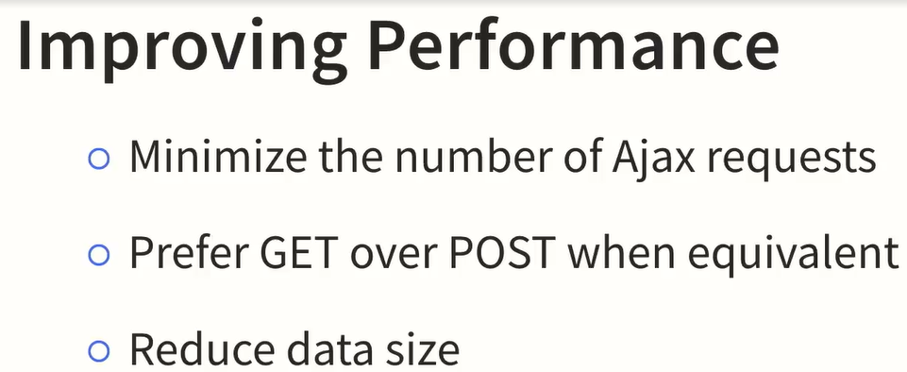

## AJAX vs Fetch

La diferencia entre **AJAX** y **Fetch** radica principalmente en su implementación, uso y las capacidades que ofrecen para realizar solicitudes HTTP en JavaScript. Aunque ambos permiten realizar peticiones asíncronas, Fetch es una interfaz más moderna y flexible, mientras que AJAX es una técnica más antigua que generalmente se implementa a través de objetos como XMLHttpRequest o bibliotecas como jQuery.

• **AJAX (XMLHttpRequest)**: El objeto XMLHttpRequest se basa en el manejo de **callbacks** (funciones que se ejecutan cuando se completa la solicitud), lo cual puede hacer que el código sea más difícil de manejar y menos legible, especialmente cuando se tienen múltiples solicitudes o lógicas complejas (a veces conocido como "callback hell").

• **Fetch API**: fetch está basado en **promesas**, lo que facilita la escritura y el manejo de código asíncrono. Las promesas permiten encadenar múltiples operaciones y usar async/await, lo que mejora la legibilidad y el manejo de errores.

• **AJAX (XMLHttpRequest)**: Cuando usas XMLHttpRequest, necesitas verificar manualmente si la respuesta fue exitosa (por ejemplo, con xhr.status) y convertir los datos según sea necesario. También tienes que manejar manualmente las respuestas como texto o JSON.

• **Fetch API**: fetch devuelve una promesa que resuelve el objeto de respuesta (Response). Luego, puedes fácilmente convertirla a JSON o a otros formatos con métodos como response.json(), response.text(), etc. Además, fetch maneja automáticamente algunos aspectos como redirecciones.

• **AJAX (XMLHttpRequest)**: XMLHttpRequest es muy compatible con navegadores más antiguos y está presente en casi todos los entornos. Esto lo convierte en una opción más segura para aplicaciones que necesitan funcionar en navegadores antiguos o con soporte limitado.

• **Fetch API**: fetch es una API moderna, lo que significa que no es compatible con versiones antiguas de navegadores (por ejemplo, Internet Explorer). Sin embargo, la mayoría de los navegadores modernos soportan fetch, y en caso de necesitar compatibilidad con navegadores antiguos, se puede usar un **polyfill**.

• **Ejemplo con XMLHttpRequest**:

var xhr = new XMLHttpRequest();

xhr.open('GET', 'https://api.example.com/data', true);

xhr.onreadystatechange = function() {

if (xhr.readyState === 4 && xhr.status === 200) {

console.log(xhr.responseText);

}

};

xhr.send();

• **Fetch API**: La API fetch es más moderna, más fácil de usar y basada en promesas. La sintaxis es más sencilla y permite manejar los datos con then y catch para las respuestas o errores.

**Ejemplo con Fetch**:

fetch('https://api.example.com/data')

.then(response => response.json())

.then(data => console.log(data))

.catch(error => console.error('Error:', error));

**Which performance guideline helps reduce the number of ajax request your app makes?** Requesting all the data you'll need from a single source in a single request.

**Which approach would enable you to improve the user experience in case a data endpoint is unreachable when a user loads the page?** Save a version of the data as a variable and add it to the DOM if your ajax request is unsuccessful.

**What is the best practice for passing data from a .then statement to the next .then statement?** Return







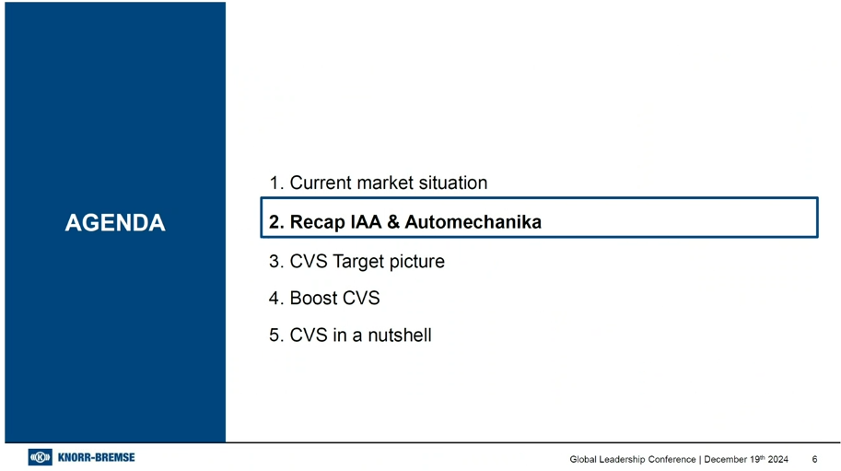





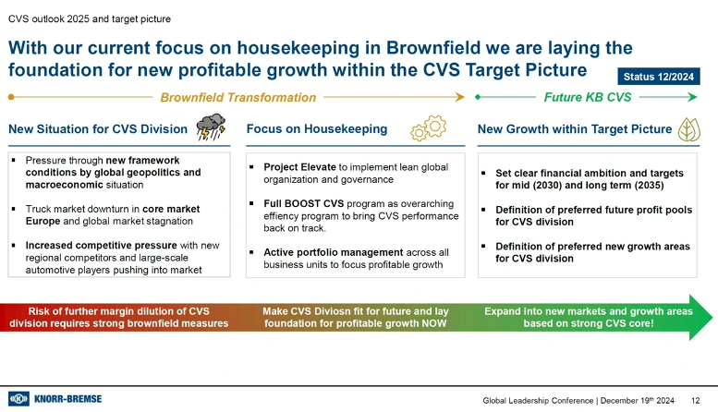

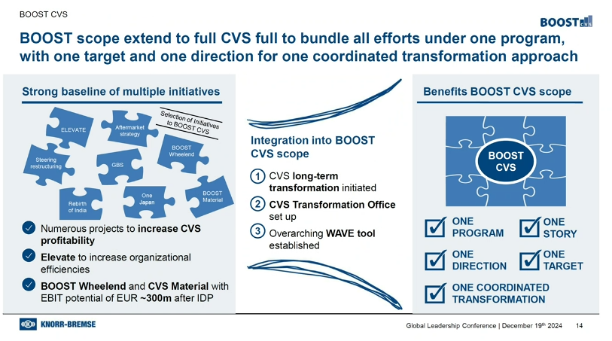

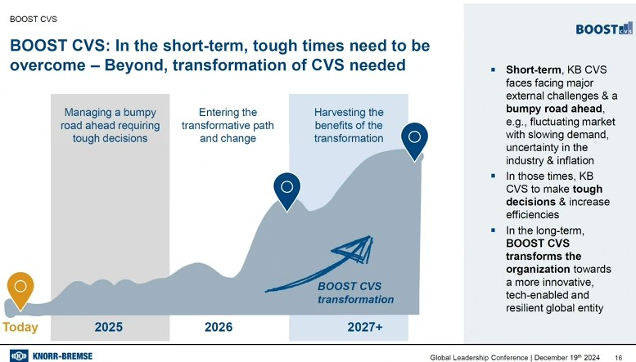



Mike

